 | C.L.G. S.Ciceam  An Creagán  Sec. Tel : 7946 8664 / 07801 445 021  40 Broagh Village  Castledawson | 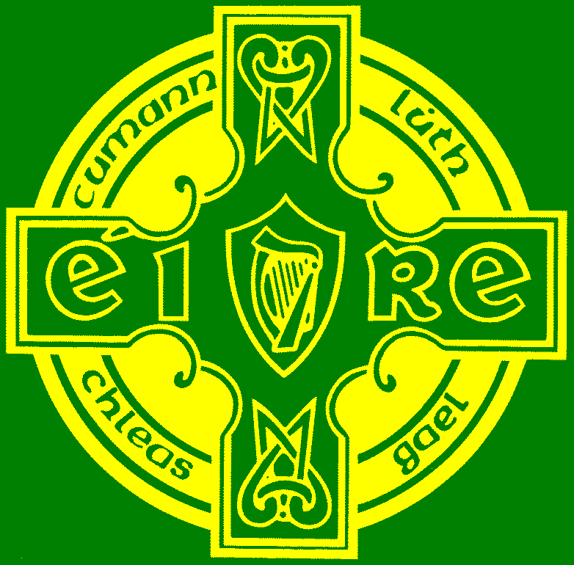

The Annual General Meeting will take place on Tuesday 2nd December 2008 at 19:00 in Creggan Social Room. The Agenda will be as follows

1. Minutes and matters arising

2. Secretary's Report

3. Treasurer's report

4. Chairman's address

5. Election of Officers

6. Motions and Recommendations

7. A.O.B.

Is mise le meas

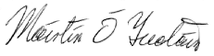

Máirtín Ó Tuatáin
Rúnaí
S.Ciceam, An Creagán

